Selfie with a king

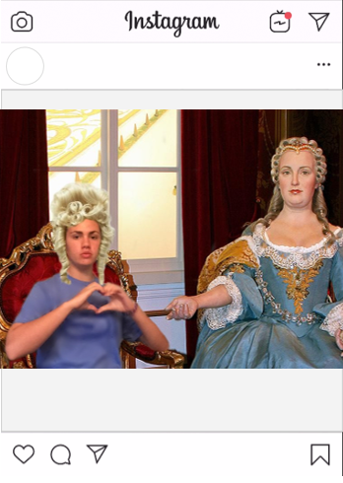

Say Hello to Maria Theresa of the Hapsburg family and the ruler of Austria. She is amazing ruler and only thinks of the advancement of her people. The court was very beautiful and decorated exquisitely and the nobles were very respectful. I especially admire the red decor! Thank you again! @maria.hapsburgg

@jordyn_reese