Peyton Velasco
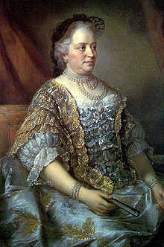
At Maria Theresa’s palace, there are gardens with mazes, fountains, a variety of gorgeous flowers, and fish ponds. There was a fenced in area that was filled with different kinds of animals, and it served as a recreational hunting ground for the court. As a wedding gift, the actual palace was in the neoclassical style for Maria Theresa, so the building was architecturally restructured. Her summer palace was filled with art, and this was the palace I was able to visit. We were taken to a pavilion in her park for breakfast, and I was able to see the guards’ rooms, the children’s rooms, the galleries, and the study rooms of some of the kids.
peyton_velasco

