Sophie’s World Assignment 1
Due: Wednesday, August 14
Sophie’s Memes

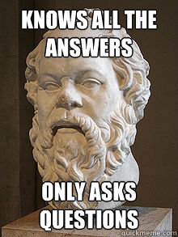

Sophie is learning more and more about each of the major philosophers. Since there are several, she needs your help remembering which philosopher introduced which philosophical idea. Your task is to create a memorable way to help her remember each one. You will be creating memes for each of the following philosophers:

- A Natural Philosopher (pick one)
- Democritus
- Socrates
- Plato
- Someone else from Athens (pick one)
- Aristotle
- Someone from the Middle Ages (pick one)
- A Renaissance Philosopher (pick one)

The memes should demonstrate an understanding of their philosophical ideas and your understanding of the book. In addition to the MEME, you should include a 1-2 sentence explanation of how the MEME exhibits the philosophical ideas of the particular philosopher.

Put these on notecards or on a poster. Be creative. Have fun with this and demonstrate understanding of the chapters and the book.

