APEH- 2020 Exam ONLY
Total Time—45 minutes

Question 1 (Document-Based Question)

Reading and writing time: 45 minutes
It is suggested that you spend 15 minutes reading/planning the documents and 30 minutes writing your response.

Directions: Question 1 is based on the accompanying documents. The documents have been edited
for the purpose of this exercise.

See ‘DBQ Planning Sheet 2020 AP Exam’

Question: Evaluate the extent to which Peter the Great can be considered a successful absolutist ruler (remember this is not a question about westernization, it is about absolutism).

Document 1
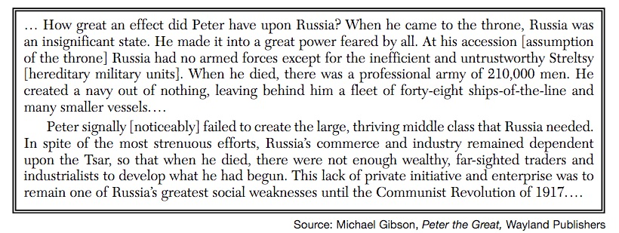
Document 2
The Great Sovereign (Peter the Great) has decreed all children between the ages of ten and fifteen of the nobility, of government clerks, and of lesser officials, must be taught mathematics and some geometry. Toward that end, students should be sent from mathematical schools [as teachers], to establish schools. During their instruction these teachers should be given food and financial remuneration. No fees should be collected from students. When they have mastered the material, they should then be given certificates written in their own handwriting. Without these certificates they should not be allowed to marry nor receive marriage certificates Source: Peter I, Decree Requiring Education of Russian Nobles, 1697

Document 3
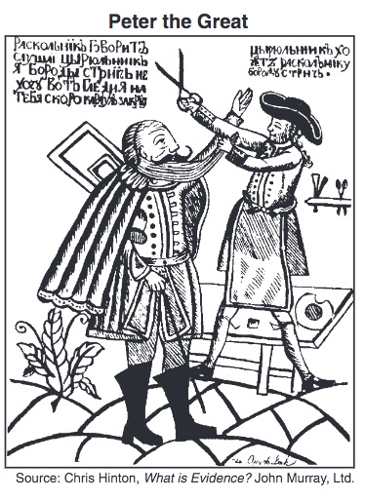
Document 4

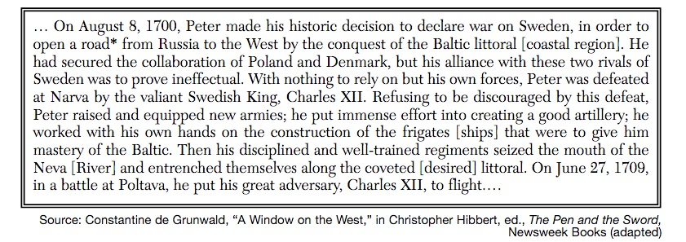

Document 5
