

LukePraser

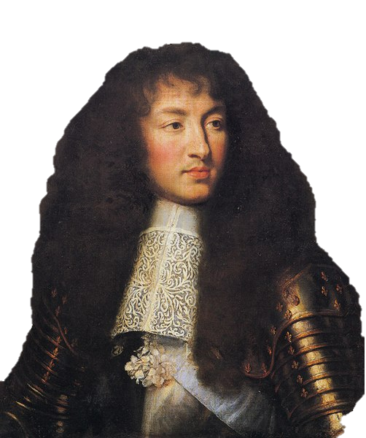



KingLouisXIV

I had the great privilege of spending a day with the great King Louis XIV yesterday. We spent the day at his immense palace in Versailles, which he said cost an equivalent of $2.5 billion dollars in my time! My favorite place in the palace was what was called the Hall of Mirrors. One wall was lined with 17 huge mirrors that faced 17 tall windows and the garden. The garden was also enormous! King Louis told me that there were 1,400 fountains throughout the garden and lawns. I met a few other nobles at the palace because they all lived at the palace in hope of being recognized by the King. After the tour of the palace, King Louis took me to a ballet in Versailles. Apparently he is a huge fan of ballet and opera. That was all that we did, and I am very thankful for the opportunity!