Honors World History Harrison High School
Summer Reading Assignment - A Little History of the World by E.H. Gombrich

Activity #1 Chart Directions:
- Read the Preface and Chapters 1 – 40.
- Below is a list of 58 terms from the novel and 10 modern events (names, events, dates, and ideas) in which we will discuss this year. You must choose 12 terms (10 novel terms and 2 modern events) and provide the following information by filling out the attached chart for each term:
  - WHO was the person or WHO was involved (historical figures, civilizations, countries, etc.)?
  - WHAT happened? Give at least 3 key facts in this section.
  - WHERE did it happen?
  - WHEN did it happen?
  - What was the SIGNIFICANCE of this person, event, date, or idea for history?
- These answers should be typed in the attached chart. You must complete a total of 12 charts.
- You MUST INCLUDE the page number for each topic that you choose!!!
- This assignment is due the first Monday of class. (Fall Semester- Monday, August 12, 2019; Spring Semester- Monday, January 17, 2020.)
- NO late papers will be accepted and NO excuses will be entertained. The assignment must be printed BEFORE class starts and should be stapled/ready to turn in at the beginning of class.
- If you moved into the district or changed schools during the last 2 weeks of summer, see your honors teacher for an extension. This will be handled on a case-by-case basis depending on when you registered for school with the School Counseling Office.
Novel Terms- Research 10 of these topics using the information provided in the novel.
- Pre-History
- Egyptian Burial Traditions
- Cuneiform
- Code of Hammurabi
- Assyrian Conquest of the Jews
- Battle of Marathon
- Darius
- Ancient Olympic Games
- Solon/Democracy
- Athens
- Sparta
- Gautama/Buddha
- Caste System
- Peloponnesian War
- Alexander the Great
- Hannibal
- Shi Huang di (Qin Emperor)
- Han Dynasty
- Julius Caesar
- Caesar Augustus
- Jesus Christ
- Nero
- Emperor Constantine
- Attila the Hun
- Justinian
- Order of the Benedictines
- Muhammad
- Charlemagne
- Chivalry
- Knights
- The Crusades
- Frederick II
- The Hundred Years War
- Leonardo da Vinci
- Medici Family
- Printing Press
- Christopher Columbus
- Montezuma
- Martin Luther
- Henry VIII
- Ignatius of Loyola/Jesuits
- Thirty Years War
- Oliver Cromwell
- Louis XIV
- 1453
- Peter the Great
- Age of Reason/Enlightenment
- Catherine the Great
- French Revolution
- Napoleon
- 1848
- Karl Marx/Communist Manifesto
- Opium Wars
- Taiping Rebellion
- Italian Unification (Cavour)
- German Unification (Bismarck)
- European Colonies
- Weapons/Strategies of WWI

Modern Events- Research 2 of these topics using library books and/or reputable online resources.

- Korean War
- Moon Landing
- Berlin Wall (Rise and Fall)
- Vietnam War
- Afghanistan/Soviet War 1980’s
- Gulf War (Desert Storm/Shield)
- September 11/War on Terror

- Darfur
- Hurricane Katrina
- Syrian War/Immigration

Activity #2 Map Directions:
- Construct a global map containing the geographic location of all 12 chosen terms.
- Plot the historical names, events, dates, and ideas on the map where they predominately took place in the world.
- Create a color-coded key with your chosen historical names, events, dates, and ideas.
- Utilize the attached map or make your own hand drawn or digital map.

Do not forget to copy and fill out the chart 12 times, one for each term.
Novel and Modern Event Chart
WHO
WHAT | 1)  2)  3)
WHERE |  | Color labeled on the map:
WHEN
SIGNIFICANCE
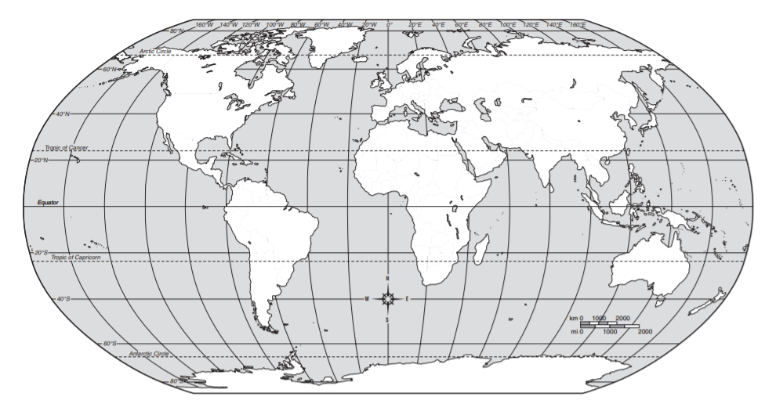
Names, Events, Dates, and Ideas Map Activity
.

Names, Events, Dates, and Ideas Map Key
Name | Color | Name | Color | Name | Color | Name | Color
1. |  | 4. |  | 7. |  | 10.
2. |  | 5. |  | 8. |  | 11.
3. |  | 6. |  | 9. |  | 12.

