Questions: Columbian Exchange Crash Course #23
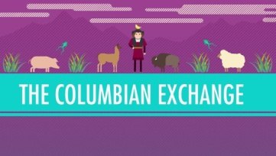
Directions: Watch the video “The Columbian Exchange: World History Crash Course #23” on www.youtube.com and answer the questions below on a separate piece of paper.
- What percentage of Native Americans died as a result of the transfer of European diseases to the New World? What diseases were the culprits?
- What were the secondary effects of European diseases on the Native American population?
- What was the one New World disease that was transferred to Afro-Eurasia as a result of the Columbian Exchange? How did it spread?
- What New World product has been responsible for the most deaths of Afro-Eurasians since its introduction to the Old World?
- Describe how the following Eurasian animals revolutionized life in the Americas…(a) the pig (b) oxen (c) horses
- What was the most significant effect of the introduction of New World plants to Afro-Eurasia?
- Describe how the following New World plants revolutionized life in Eurasia… (a) potato (b) manioc, a.k.a. cassava (c) sweet potato (d) corn
- What was the significance of the transfer of people that occurred as a result of the Columbian Exchange?
- In your opinion, should the world today be grateful for the Columbian Exchange? Why?

------------------------------------------------------------------------------------------------------------------------------------------

Questions: Columbian Exchange Crash Course #23
Directions: Watch the video “The Columbian Exchange: World History Crash Course #23” on www.youtube.com and answer the questions below on a separate piece of paper.
- What percentage of Native Americans died as a result of the transfer of European diseases to the New World? What diseases were the culprits?
- What were the secondary effects of European diseases on the Native American population?
- What was the one New World disease that was transferred to Afro-Eurasia as a result of the Columbian Exchange? How did it spread?
- What New World product has been responsible for the most deaths of Afro-Eurasians since its introduction to the Old World?
- Describe how the following Eurasian animals revolutionized life in the Americas…(a) the pig (b) oxen (c) horses
- What was the most significant effect of the introduction of New World plants to Afro-Eurasia?
- Describe how the following New World plants revolutionized life in Eurasia… (a) potato (b) manioc, a.k.a. cassava (c) sweet potato (d) corn
- What was the significance of the transfer of people that occurred as a result of the Columbian Exchange?
- In your opinion, should the world today be grateful for the Columbian Exchange? Why?

